A PRELIMINARY MINI PROJECT REPORT ON

“Placement Preparation Platform”

SUBMITTED TOWARDS THE PARTIAL FULFILLMENT OF
THE REQUIREMENTS OF

BACHELOR OF TECHNOLOGY (Third Year B. Tech.)
Academic Year: 2025-26

Name | PRN
Ranjit Chavan | 123B1B103
Prathmesh Doiphode | 123B1B110
By:

Under The Guidance of
Prof. Shailesh B. Galande
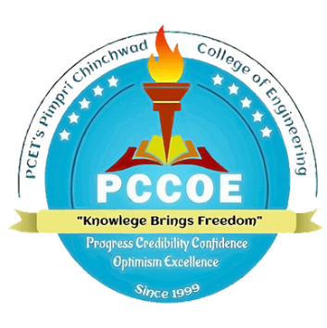

DEPARTMENT OF COMPUTER ENGINEERING,
PIMPRI CHINCHWAD COLLEGE OF ENGINEERING
SECTOR 26, NIGDI, PRADHIKARAN


PIMPRI CHINCHWAD COLLEGE OF ENGINEERING
DEPARTMENT OF COMPUTER ENGINEERING,

CERTIFICATE

This is to certify that, the mini project entitled

“Placement Preparation Platform”
is successfully carried out as a mini project for Full Stack Development
Laboratory and successfully submitted by following students of “PCET’s
Pimpri Chinchwad College of Engineering, Nigdi, Pune-44”.

Under the guidance of Prof. Shailesh B. Galande
In the partial fulfillment of the requirements for the Third Year B. Tech.

(Computer Engineering)

Name | PRN
Ranjit Chavan | 123B1B103
Prathmesh Doiphode | 123B1B110

Prof. Shailesh B. Galande
Project Guide

Abstract:

Index
Chapter | Contents |  | Page no.
1 |  | Introduction
 | a.
 | b.
 | c.
 | d.

Chapter 1: Introduction
a) Problem Statement
b) Project Idea
c) Motivation
d) Scope
e) Literature Survey/ Requirement Analysis

Chapter 2: Project Design
a) H/W, S/W, resources, requirements &amp; their detail explanation
b) Dataset Design
c) Hour’s estimation
Chapter 3: Module Description

a) Block diagram with explanation of each module
b) Comparative study
Chapter 4: Results &amp; Discussion
a) Source code
b) Screenshots including GUI
c) Test cases
Chapter 5: Conclusion
References
Annexure:
Mini Project Plagiarism Report.

